1. Login to Karstadt Console and login to one of the three account.

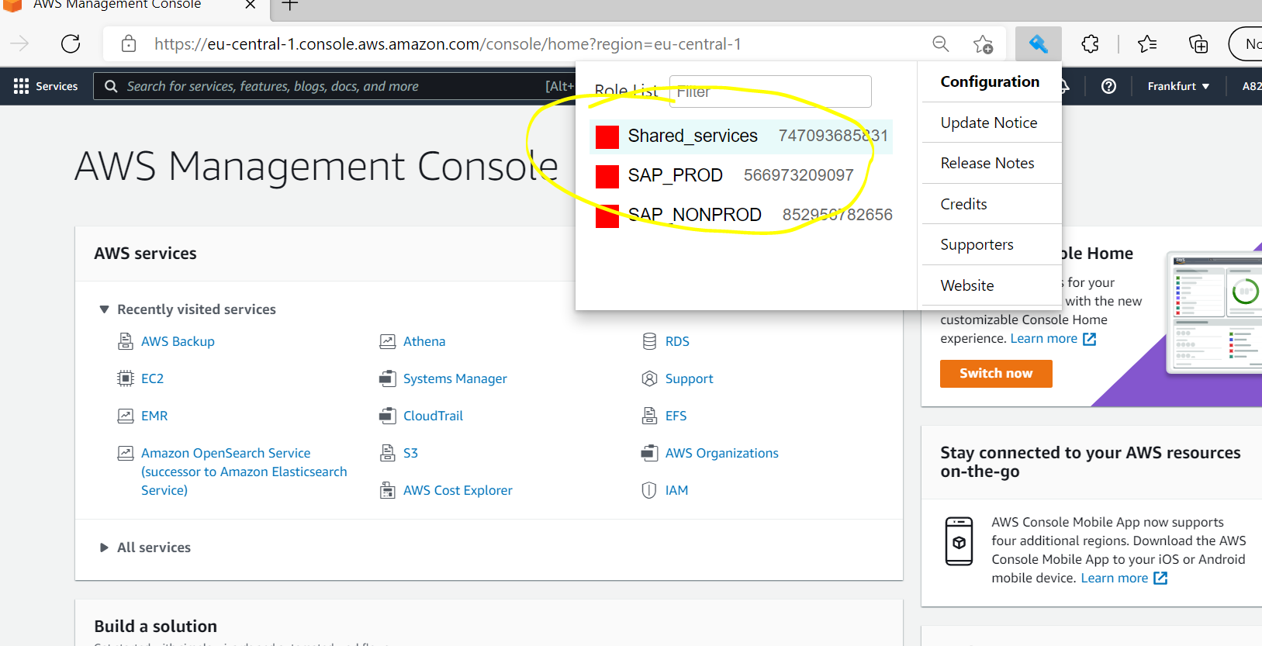

1. Search AWS Backup and go into AWS Backup.

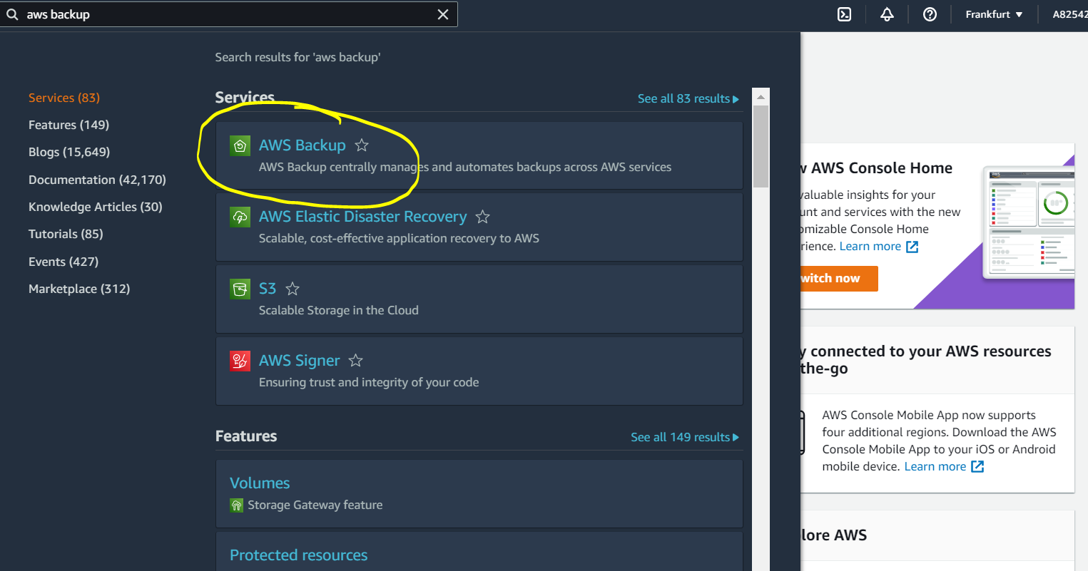

1. Click on Dashboard

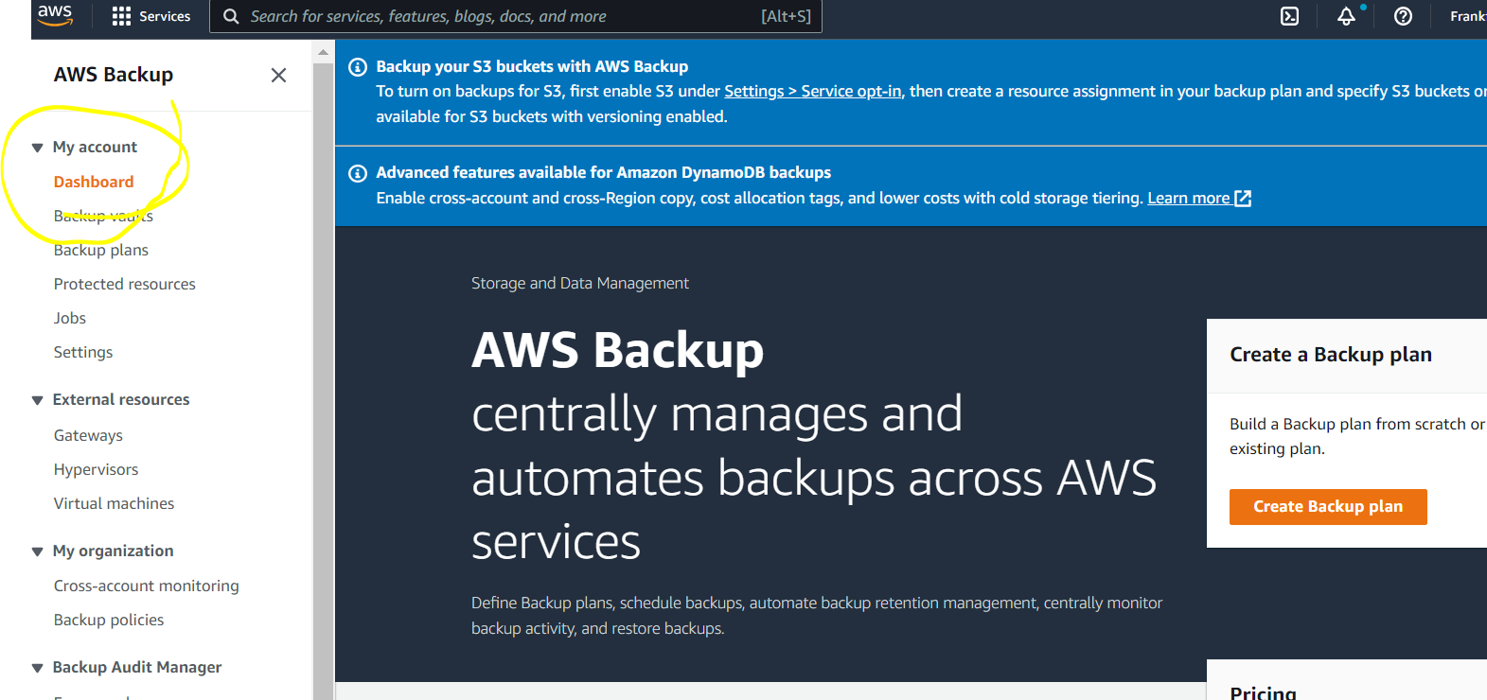

1. Then scroll down and check “Backup jobs in last 24 Hours”.

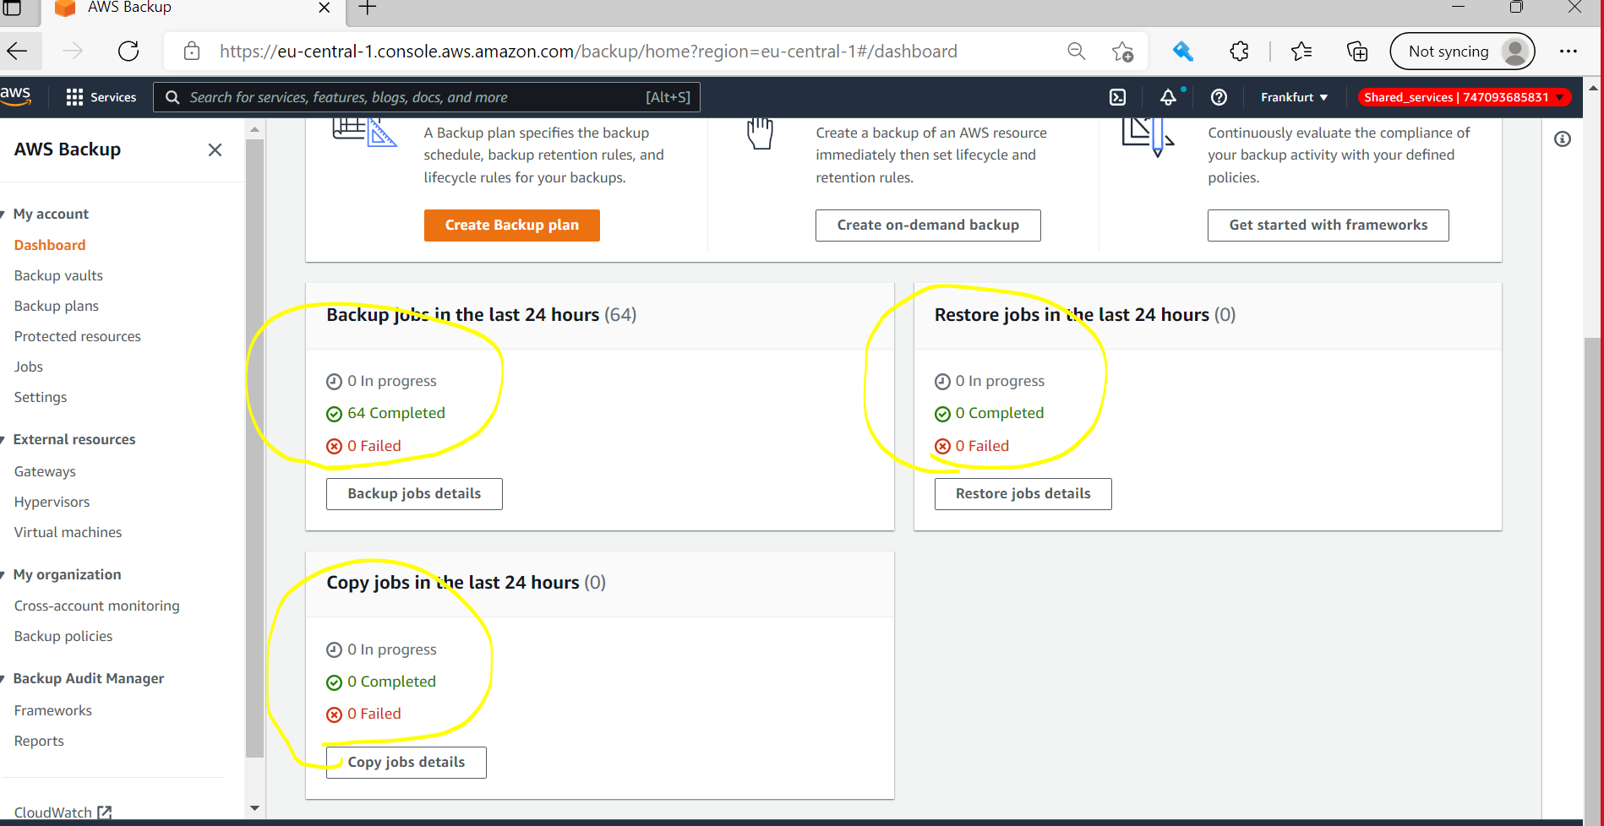

1. Check Similarly for other accounts as well.

* Shared Services
* SAP_PROD
* SAP_NONPROD